**PROBLEM-SOLUTONFIT ProjectTitle:ANOVELMODELFORHANDWRITTEN TEAMID:** **PNT2022TMID01551**

DIGITRECOGNITIONSYSTEM

**CONSTRAINS:**

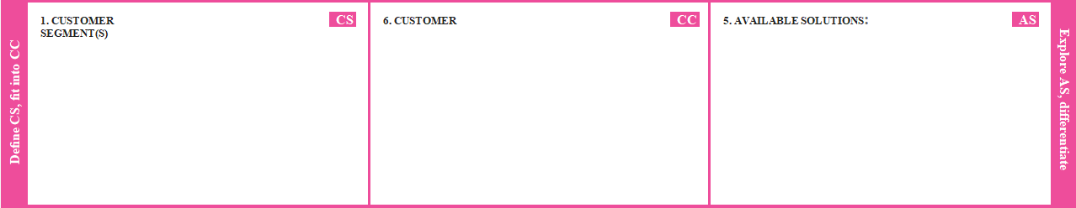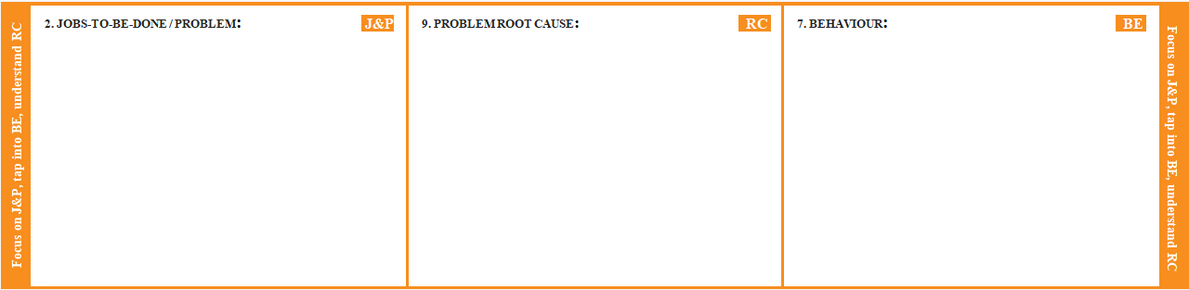

Thebankmanagerrecognizethedigitbut Thebankmanager canpredictthecheque

Mycustomerisabankmanager hetryingto isnotclearbecauseofuniquestyleofhandwriting. handwritten digittocompletethetransaction.

Recognizethedigitsin cheque.

|  |  |  |
| --- | --- | --- |
| Thechequehand writingisnotclear | Problemcauseishandwrittenisnot clear | Thecustomer wantto moneytransaction |
| butthemoneytransactioncannotcompleted | Hencethetransactionisnotcomplete | Butthebankmanagerdidn’tunderstandthe |
|  |  | handwrittenanddigithencethetransactionisnot |
|  |  | compete |

|  |  |  |  |  |
| --- | --- | --- | --- | --- |
| **IdentifystrongTR&EM** | **3.TRIGGERS TR**  Problem is hand written is notcleareachcheck takemore timethe bankmanger had irritated | **10.YOURSOLUTION SL**  Use the MINIST Dataset torecognize handwritten digits convolutionalneuralnetworkmodelcreatedusingpytorchlibraryto solve theproblem | **8.CHANNELSofBEHAVIOUR CH**  Thecustomer wanttomoneytransactionBut thebankmanagerdidn’tunderstandthe handwritten and digit it’s take more time hencethetransactionis notcompetehe hadannoyed | **Extractonline&ofﬂineCHofBE** |
| **4.EMOTIONS:**  **EM**  The cheque handwrittendigitis not understand it takemoretimethehence  bankmanagerannoyed |  |